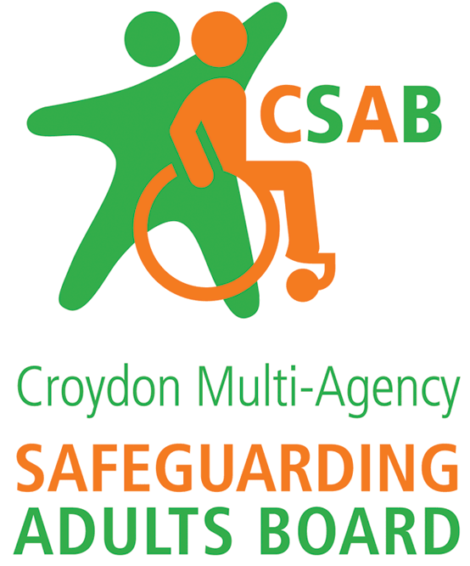

Safeguarding Adults Review Request Form

Croydon Safeguarding Adult Board considers every SAR request against the criteria [please see section 4 of the SAR Framework or the SAR 7 minute briefing].

The SAR Sub Group requires as much information as possible to enable members to make a proportionate decision as to how to respond to a SAR request, ensuring, if the case is accepted for a review, that maximum learning can be achieved. Please complete the form below providing relevant information which will assist the decision making.

- Details of adult at risk:

Name
Address
Date of birth
Date of death (if applicable)
Ethnicity
GP (if known)
Family/ next of kin/ advocate/ representative

- Details of individual/ organisation requesting the SAR:

Date of Request
Name
Position/ designation
Organisation
Address
Contact telephone
Contact email

Authorising manager
Position/ designation
Contact telephone
Contact email
- Details of the Case

Brief summary of concerns which triggered this request:

- Chronology of Events

Date | Activity/Action | Who
An example:  December 2016 | Concerns raised via email due to non engagement | Utilities Company
Any other relevant information:

5. Why should this be a SAR?

- Reason:

- Lessons to be learned:

- Agencies involved:

Do you believe a statutory SAR is required in response to this case? | Yes |  | No
Has any other learning/ review process taken place or commenced? Eg IMRs, SI’s etc | Yes |  | No
If yes, please specify process, learning identified, how it was disseminated and impact

Please submit your form via secure email to csab@croydon.gov.uk

