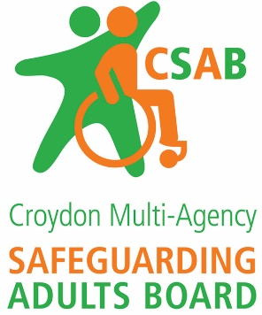

**Liberty Protection Safeguards**

**– DoLS Replacement Scheme**

***Preparing for Implementation***

**Venue -** X-Change Hub, Marco Polo House 3-5 Lansdowne Road,

Croydon, Surrey, CR0 2BX

***Two Identical sessions***

***9.00 am -12.30pm & 1.00pm– 4.00 pm***

**Aim**

This half day workshop aims to provide an overview and analysis of the legislation to replace DoLS with the *Liberty Protection Safeguards*. To give participants a basic awareness of how the new Liberty Protection Safeguards (the replacement for the Deprivation of Liberty Safeguards) will apply to their work settings.

**Target Group**

This session is for all the Health and Social Care professionals (Social Workers, Care managers, Team Managers, Senior Management staff, Occupational & Physio Therapists, Nursing staff) who requires awareness or overview of the Liberty Protection Safeguards.

* Overview of the Mental Capacity Amendment act 2019
* Responsibilities: including new terms - Responsible Body, LPS- Statutory new roles
* Key Messages and their likely impact – DoLS vs LPS (LPS main changes)
* The “Pre-Authorisation Review” - who is responsible and what is involved
* The Conditions/Assessments
* 16 & 17 year olds: LPS Scheme
* The Challenges - Decision making for care, treatment and discharge
* Authorizing arrangements
* The individual’s Rights and Protections: advocacy, appeals, reviews
* The Role of the Care Homes etc. (Managing Authority)
* LPS in Acute Care settings (Hospitals)
* Know what to do if the person objects to the proposed arrangements
* Be able to explain the purpose and role of the “Approved Mental Capacity Professional”
* Understand the safeguards that are put in place by the authorisation, and be able to explain how the person can challenge an authorisation.

**More information and to book, go to:** [**Croydon Learning**](https://croydon.learningpool.com/course/view.php?id=703)