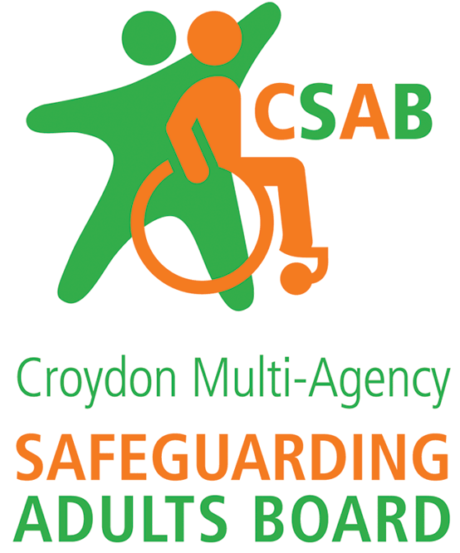

Croydon CSAB Safeguarding Adults Review request form

This SAR request form corresponds to paragraph 3.1 of the Croydon SAR Framework.

Croydon CSAB considers every SAR request on the basis of whether it meets the criteria for a Safeguarding Adults Review (see section 2 of the Croydon SAR Framework).

The Board needs as much information as possible to enable members to make a proportionate decision as to how to respond to a SAR request, ensuring, if the case is accepted for a review, that maximum learning can be achieved. Please therefore complete as much information on this form as possible. If you have any questions, please do not hesitate to contact the Safeguarding Development Officer on CroydonCSAB@Croydon.gov.uk or on 020 7974 3942.

Details of individual/ organisation requesting the SAR:

Name
Position/ designation
Organisation
Address
Contact telephone
Contact email

Authorising manager
Position/ designation
Contact telephone
Contact email

Date of request

Details of adult at risk:

Name
Address
Date of birth |  | Date of death (if applicable)
Ethnicity
GP (if known)
Family/ next of kin/ advocate/ representative
Health and/ or other presenting needs:

Details of person/ organisation alleged responsible for harm:

Name
Address
Date of birth |  | Date of death (if applicable)
Ethnicity
GP (if known)
Relationship to adult at risk
Health and/ or other presenting needs:

Details of SAR request:

Brief outline of the case/ incident (with dates and locations if known)
Summary of why this case meets the criteria for a SAR (see section 2, Croydon SAR Framework)
Please establish the link between cause of death/ harm and the (suspected) abuse/ neglect. Please include views of the adult/ family/ carer where known.

Do you believe a statutory SAR is required in response to this case? | Yes |  | No
What learning do you think can be achieved through a review of this case?
Has any other learning/ review process already been followed (e.g. internally)? | Yes |  | No
If yes, please specify the review conducted, learning identified, how it was disseminated and impact
List of individuals and their agencies/ service providers known to be involved in the case
Any other relevant information that will help Croydon CSAB decide whether an SAR is required

To protect personal/ sensitive data this form must only be sent by secure email or post.

Submit your request form by post to:

Croydon CSAB
Croydon Safeguarding Adults Board
Floor 2
Bernard Weatherill House
8 Mint Walk
Croydon CR0 1EA

Or submit by secure email:

In line with the Croydon CSAB information sharing agreement, emails containing personal, sensitive or confidential information (including attachments) must be encrypted and sent through secure channels.
Both the sending and recipient email address must be secure.

Croydon CSAB uses CJSM and egress as encryption tools. SAR requests can be sent securely to:

- CroydonCSAB@Croydon.gov.uk.cjsm.net from nhs.net, Police National Network (pnn), gscx and cjsm accounts.

- CroydonCSAB@Croydon.gov.uk (egress enabled account) from any other egress enabled account, including non-public bodies, third sector organisations and individuals who are not part of any of the encryption schemes listed in point i) above. The sender will need to set up a free egress account by visiting egress.com.

- CroydonCSAB@Croydon.gov.uk from another @Croydon.gov.uk account only.

